TECHPORCH INCORPORATED

DragON Verification Guide
Authenticate with Your Personalized Drag Sequences
Version 2.0 | Product Documentation | April 2026

1. Introduction

DragON replaces traditional password entry with a graphical, drag-based authentication system. Instead of typing a password, you prove your identity by performing personalized drag sequences on an image grid — a faster, more intuitive way to log in to your Windows PC.
The DragON experience has two stages:
- Enrollment — A one-time setup where you choose a theme, select tiles from an image grid, and create your personalized drag sequences. This is covered in the separate Enrollment Guide.
- Verification — Every time you log in or unlock your computer, you reproduce your drag sequences to authenticate. This guide covers the verification process.

📝 Before You Begin
This guide assumes you have already completed enrollment and have set up your drag sequences. If you have not yet enrolled, please refer to the DragON Enrollment Guide first.

2. What You’ll See at the Login Screen

When you start your PC or lock your computer (Windows key + L), the Windows login screen appears. DragON is listed as a credential provider alongside standard Windows options such as Password and PIN.
To begin graphical authentication, select DragON from the sign-in options. The verification screen will appear, displaying:
- Theme selector icons along the top of the tile grid
- Image tile grid showing themed images you can interact with
- Instruction text guiding you through the verification steps
- Back-arrow icon in the top-left corner to return to standard Windows login
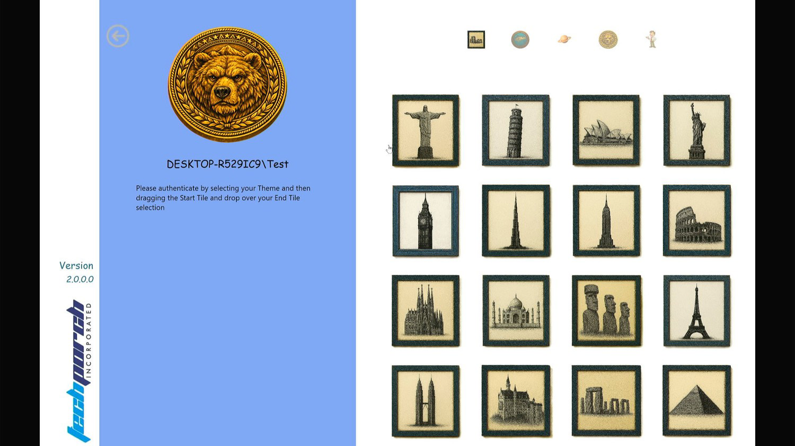
Figure 1: The DragON verification screen with themed tile grid and on-screen instructions.

3. Step-by-Step Verification Process

Follow these steps each time you log in or unlock your Windows PC using DragON.

Step 1: Select Your Theme
The verification screen displays theme icons at the top of the tile grid. Available themes include Animals, Landmarks, Space, Ocean, Cartoon, and others.
- Locate the row of theme icons at the top of the screen.
- Click the icon for the same theme you selected during enrollment.
- The tile grid will update to display the images for your chosen theme.

❗ Important
You must select the correct theme — the same one you used during enrollment. Selecting a different theme will display a different set of tiles, and your drag sequences will not match.

Step 2: Perform Your First Drag Sequence
Once the correct theme is displayed, perform your first drag gesture:
- Look at the tile grid and locate your Start Tile — the tile you chose as your starting point during enrollment.
- Click and hold on your Start Tile, then drag to your End Tile.
- Release the mouse button (or lift your finger on a touch screen) on the End Tile.
This drag gesture must match your first drag sequence exactly as you set it up during enrollment — same Start Tile, same End Tile.

Step 3: Perform Additional Drag Sequences (If Applicable)
If you enrolled with multiple drag sequences, continue performing each drag gesture in order:
- After completing your first drag, the system will prompt you for the next sequence.
- Perform each subsequent drag in the exact same order as you set them up during enrollment.
- Each successful drag is validated in sequence before moving to the next.

💡 Tip
Think of your drag sequences like a combination lock — each drag is a step in the combination, and they must be performed in the correct order.

Step 4: Authentication Complete
Once all drag sequences are correctly performed in the right order, authentication succeeds. Windows will immediately log you in or unlock your desktop.
✔ You’re in! Your desktop will appear and you can begin working.

Step | Action | Key Point
1. Select Theme | Click your theme icon at the top of the grid | Must match your enrollment theme
2. First Drag | Drag from Start Tile to End Tile | Must match your first enrolled sequence
3. Additional Drags | Repeat for each enrolled sequence | Perform in the same order as enrollment
4. Done | Windows logs you in automatically | All sequences validated ✔

4. If You Make a Mistake

If you select the wrong tile or perform a drag in the wrong order, don’t worry. The system is designed to let you try again.
- If a drag does not match your enrolled sequence, or you realize that you made a mistake.
- Simply restart from the first drag sequence and try again.
- The system will reset and allow you to perform all sequences from the beginning.

💡 Tip
Take your time. There is no time limit on performing your drag sequences. Accuracy is more important than speed.

5. Canceling DragON Authentication

You can cancel DragON authentication at any time and return to the standard Windows login screen.
To cancel: Click the Back-Arrow icon (←) located at the top-left corner of the verification screen.
This will take you back to the standard Windows login and credential selection screen. From there, you can choose an alternative sign-in method:
- Windows Password — Type your standard account password
- PIN — Enter your Windows Hello PIN
- Other credential providers — Any additional sign-in methods configured on your PC

📝 Note
This is useful if you temporarily cannot remember your drag sequences. You can always fall back to your standard Windows credentials and return to DragON later.

6. Tips for Successful Verification

Keep these tips in mind to ensure smooth, successful authentication every time:

# | Tip | Details
1 | Remember your theme | Always select the same theme you used during enrollment. The theme determines which tiles appear in the grid.
2 | Remember the order | If you set up multiple drag sequences, they must be performed in the same order as enrollment.
3 | Remember your tiles | Know which Start Tile and End Tile you chose for each drag. Visualize them before you begin.
4 | Practice | The more you use DragON, the more natural it becomes — like remembering a gesture pattern or phone unlock swipe.
5 | Keep it secret | Don’t share your drag sequences with others, just as you wouldn’t share your password. Your sequences are your credential.

7. Trial Version Note

❗ Trial Version
If you are using a TRIAL version of DragON, your verification will consist of a single drag sequence only. You will select your theme, perform one drag from your Start Tile to your End Tile, and authentication will be complete. To unlock the full multi-sequence experience, upgrade to the licensed version of DragON.

8. Need Help?

If you encounter any issues with DragON verification, the following resources are available:
- Forgotten your drag sequences? — Contact your system administrator to reset your enrollment. Once reset, you can re-enroll with new drag sequences using the Enrollment Guide.
- Need to log in immediately? — Click the back-arrow icon (←) on the verification screen to return to standard Windows authentication. Use your password or PIN to sign in.
- Product support and documentation — Visit www.Techporch.com for the latest product information, FAQs, and technical support resources.

💡 Remember
DragON is an additional authentication option — your standard Windows login methods remain available at all times. You always have a way to access your computer.

DragON Verification Guide | Version 2.0 | Techporch Incorporated
© 2026 Techporch Incorporated. All rights reserved. | www.Techporch.com

